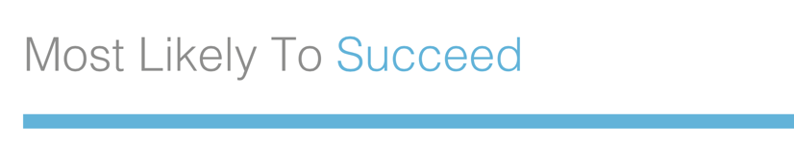
FOR IMMEDIATE RELEASE
Contact: Jane Doe
Phone: (555) 555 5555
Email: JDoe@anywhere.com

[NAME OF CITY/ORGANIZATION] HOSTS SCREENING OF SUNDANCE-SELECTED DOCUMENTARY, MOST LIKELY TO SUCCEED
[CITY/ORGANIZATION] is one of more than 1,500 communities working to re-imagine the purpose of education
[CITY, DATE] On [DATE OF EVENT], the [CITY/ORGANIZATION] will take part in Most Likely to Succeed’s worldwide campaign to re-imagine education. The acclaimed film Most Likely to Succeed offers an inspiring look at what students and teachers are capable of—if we have the vision and courage to transform our schools. Directed by acclaimed documentarian Greg Whiteley, the film has been an official selection of two dozen of the world’s top film festivals, including Sundance, Tribeca, and AFI DOCS. It’s been featured at leading conferences on education, including ASU/GSV, SxSWedu, Harvard/GoldmanSachs, and NewSchools Venture Fund. Audience members call it the most compelling film ever done on the topic of school. In the past year, more than 2,300 communities have booked a screening of Most Likely to Succeed.
The purpose of this event is to foster meaningful discussion among educators, administrators, parents, and students about how current obstacles can be overcome and steps towards change can be taken on a local level. Born out of these conversations is a community-wide commitment to moving forward; transformational initiatives are undertaken and real change is ignited. This event is open to the public. Please visit mltsfilm.org for more information about the film and movement.
The screening tour is being co-organized by The Future Project, a fast-growing non-profit transforming inner-city public schools across the country and with a big vision for America’s future.
For additional information, please contact Jane Doe.
###

